**Appendix xx: Results from an online survey of NITAGs’ needs and challenges**

**1. Select one category that describes your current NITAG role?**

Answers were provided by the following members representing a total of 23 countries.

1. Chairs (n=15; 25%)
2. Core members (n=31; 60%): representing 13 countries (*4 countries different to those of the chairs*). One respondent submitted a scanned handwritten questionnaire. Some answers from the questionnaire were illegible and therefore, excluded from the analyses.
3. Secretariat (n=14; 23%): representing 12 countries (*4 countries different to those of chairs and secretariat*)

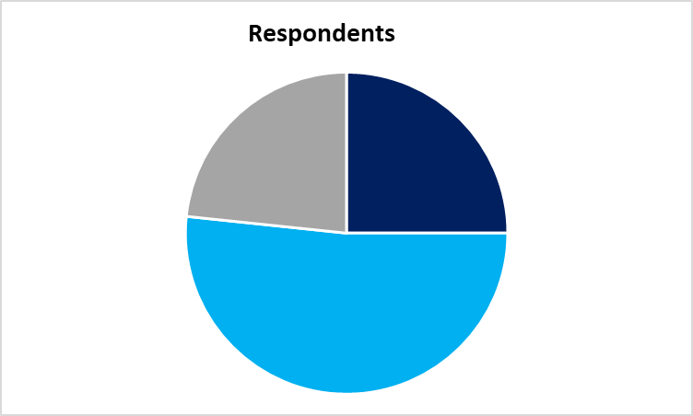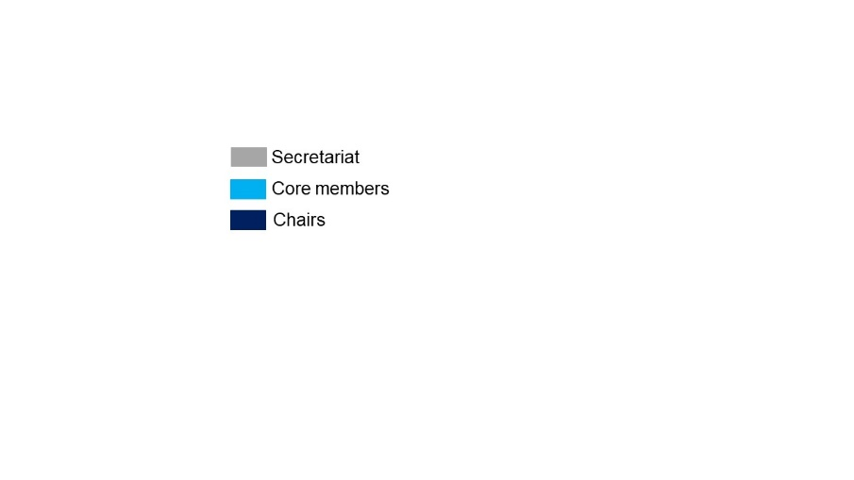

*Note: Liaison (n=3): representing 3 countries (2 countries represented by those of the Chairs and 1 country represented by those of Core members and Secretariat). Data from the ex-officio was not included in the final analyses because of low sample size and more importantly, the needs and challenges of these members are secondary to the other membership categories.*

**2. How old (years) is the NITAG in your country?**

**Chairs:** the youngest and oldest NITAG is <1 and 23 years old respectively, with a median age of 4 years.

**Core members:** the youngest and oldest NITAG is 1 and 27 years old respectively, with a median age of 3.5 years

**Secretariat:** the youngest and oldest NITAG is 4 and 26 years old respectively, with a median age of 6 years.

|  |  |  |  |
| --- | --- | --- | --- |
| **Country code** | **Chairs** | **Core members** | **Secretariat** |
| A | 4 | 2 | N/A |
| B | 2 | N/A | N/A |
| C | 4 | 3 & 4 | 4 |
| D | 5 | N/A | N/A |
| E | <1 | 1, 1 & 1 | N/A |
| F | 3 | 2, 3, 3, 3 & 4 | N/A |
| G | 4 | N/A | N/A |
| H | 9 | 4 & (error) | 4, 8 & 10 |
| I | 2 | N/A | N/A |
| J | 5 | 5 & 5 | 5 |
| K | 23 | 27 & 27 | 26 |
| L | 4 | 2 & 2.5 | N/A |
| M | 5 | N/A | 6 |
| N | 7 | 7 & 7 | 7 |
| O | 2 | N/A | N/A |
| P | N/A | 1 | N/A |
| Q | N/A | 9 & 9 | N/A |
| R | N/A | 3, 4, 5, 5, 5 & 6 | 6 |
| S | N/A | 3 | 4 |
| T | N/A | N/A | 7 |
| U | N/A | N/A | 10 |
| V | N/A | N/A | 4 |
| W | N/A | N/A | 5 |

**3. In which country is the membership of your NITAG?**

Answers were provided by the following members representing a total of 23 countries:

1. Chairs (n=15): representing 15 countries
2. Core members (n=31): representing 13 countries (*4 countries different to those of the chairs*).
3. Secretariat (n=14): representing 12 countries (*4 countries different to those of chairs and secretariat*)

23 out of 29 (79%) countries that were canvassed responded. The response rate was 32%.

**4. How many core members does your NITAG currently have?**

**Chairs:** the average number is 12.

**Core members:** the average number is 15.

**Secretariat:** the average number is 12.

|  |  |  |  |
| --- | --- | --- | --- |
| **Country code** | **Chairs** | **Core members** | **Secretariat** |
| A | 11 | Not reported | N/A |
| B | 5 | N/A | N/A |
| C | 6 | 6 & 5 | 12 |
| D | 11 | N/A | N/A |
| E | 13 | 11, 16, Not reported | N/A |
| F | 15 | |  | | --- | | 15, 15, 10, 10, Not reported | | N/A |
| G | 8 | N/A | N/A |
| H | 16 | 17, Not sure | 14, 16 |
| I | 12 | N/A | N/A |
| J | 13 | 13, 15 | 13 |
| K | 14 | 15, 14 | 15 |
| L | 20 | 20, 20 | N/A |
| M | 8 | N/A | 8 |
| N | 11 | 15, 15 | 15 |
| O | 11 | N/A | N/A |
| P | N/A | 6 | N/A |
| Q | N/A | 15, Not reported | N/A |
| R | N/A | 15, 15, 15, 15, 16, 16 | N/A |
| S | N/A | 15 | 14 |
| T | N/A | N/A | 11 |
| U | N/A | N/A | 10 |
| V | N/A | N/A | 6 |
| W | N/A | N/A | 10 |

**5. What are your thoughts on the idea of a Regional Scientific Hub that will provide technical/scientific support to NITAGs in Africa?**

Answers were provided by the following members representing a total of 23 countries:

1. Chairs (n=15, representing 15 countries): **14 (93%)** indicated they support the idea. Wording of the responses varied as follows: “very good”; “excellent”; “great”; “reasonable”; “really needed” etc.

For the response **1 (7%)** that did not indicate support, the response was as follows: “Unlikely that scientific hub will be successful. More worthy to pool across areas in same region to maximise on skill and allow for cross-country support in real terms”.

1. Core members (n=31, representing 13 countries): All **31 (100%)** members supported the idea of setting up a RSH. Wording of the responses varied as follows: “very good”; “very timely”; “great”; “positive move”; “highly needed” etc.
2. Secretariat (n=14 representing 12 countries): All **14 (100%)** members supported the idea of setting up a RSH. Wording of the responses varied as follows: “opportunity to share experiences and good practices”; “extremely necessary”; “great”; “relevant”; “great initiative” etc.

**6**. **List the priority needs of your NITAG that the Regional Scientific Hub can address**

Answers were provided by the following members representing a total of 23 countries:

1. Chairs (n=15): representing 15 countries
2. Core members (n=30): representing 13 countries (*4 countries different to those of the chairs*). A questionnaire was excluded as it was not legible (handwritten)
3. Secretariat (n=14): representing 12 countries (*4 countries different to those of chairs and secretariat*).

|  |  |  |  |
| --- | --- | --- | --- |
| **Theme** | **Chairs (n=15)** | **Core M (n=30)** | **Secretariat (n=14)** |
| Training (Vaccinology) | 33% | 47% | 71% |
| Training & support (EIDM) | 100% | 100% | 100% |
| Networking, Collaborations & Communications | 67% | 60% | 50% |
| Funding | 27% | 23% | 57% |

“Country ownership” is another theme that came up across all membership categories, but at low frequency.

**7. List all the challenges that your NITAG faces and considers as most interfering to its function.**

Answers were provided by the following members representing a total of 23 countries:

1. Chairs (n=15): representing 15 countries
2. Core members (n=29): representing 13 countries (*4 countries different to those of the chairs*). A questionnaire was excluded as it was not legible (handwritten) and one respondent did not answer the question
3. Secretariat (n=14): representing 12 countries (*4 countries different to those of chairs and secretariat*).

|  |  |  |  |
| --- | --- | --- | --- |
| **Theme** | **Chairs (n=15)** | **Core M (n=29)** | **Secretariat (n=14)** |
| EIDM training & support | 7% | 34% | 57% |
| Recommendation to action | 33% | 3% | 21% |
| Administrative & Operational support | 73% | 93% | 57% |
| Networking, Collaborations & Communications | 27% | 7% | 0% |
| Funding | 73% | 66% | 86% |

“EIDM training & support” was listed mainly under needs, however, some respondents listed it as a challenge too.

**8. Select all the WHO functionality indicators that your NITAG currently fulfils**

Answers were provided by the following members representing a total of 23 countries:

1. Chairs (n=15): representing 15 countries (A to O)
2. Core members (n=29): representing 13 countries (*4 countries different to those of the chairs* (P to S). Two members did not respond.
3. Secretariat (n=14): representing 12 countries (*4 countries different to those of chairs and secretariat* (T to W).

**Overall, 18 of the 23 (78%) countries met all the 6 WHO functionality indicators**

|  |  |  |  |  |  |  |
| --- | --- | --- | --- | --- | --- | --- |
|  | **Meets WHO functionality indicators** | | | | | |
| **Country** | 1 | 2 | 3 | 4 | 5 | 6 |
| A | No | Yes | Yes | Yes | Yes | No |
| B | No | No | No | No | Yes | Yes |
| C | Yes | Yes | Yes | Yes | Yes | Yes |
| D | Yes | Yes | Yes | Yes | Yes | Yes |
| E | Yes | Yes | Yes | Yes | Yes | Yes |
| F | Yes | Yes | Yes | Yes | Yes | Yes |
| G | Yes | Yes | Yes | Yes | Yes | Yes |
| H | Yes | Yes | Yes | Yes | Yes | Yes |
| I | Yes | Yes | Yes | No | No | Yes |
| J | Yes | Yes | Yes | Yes | Yes | Yes |
| K | Yes | Yes | Yes | Yes | Yes | Yes |
| L | Yes | Yes | Yes | Yes | Yes | Yes |
| M | Yes | Yes | Yes | Yes | Yes | No |
| N | Yes | Yes | Yes | Yes | Yes | Yes |
| O | Yes | Yes | Yes | Yes | Yes | Yes |
| P | No | Yes | Yes | Yes | Yes | Yes |
| Q | Yes | Yes | Yes | Yes | Yes | Yes |
| R | Yes | Yes | Yes | Yes | Yes | Yes |
| S | Yes | Yes | Yes | Yes | Yes | Yes |
| T | Yes | Yes | Yes | Yes | Yes | Yes |
| U | Yes | Yes | Yes | Yes | Yes | Yes |
| V | No | Yes | Yes | No | No | No |
| W | Yes | Yes | Yes | Yes | Yes | Yes |
| **Summary** | **19/23**  **(83%)** | **22/23**  **(97%)** | **22/23**  **(97%)** | **20/23**  **(87%)** | **21/23**  **(91%)** | **20/23**  **(87%)** |

WHO functionality criteria

1.Having a legislative or administrative basis

2.Having formal terms of reference

3.Having at least five areas of expertise represented among its membership

4.Having at least one meeting per year

5.Distribution of agenda & background documents at least one week prior to meetings

6.Having a mandatory disclosure of conflict of interest

**9. Name any key professional expertise that should be represented in your NITAG but is currently NOT REPRESENTED**

Related professional expertise was put on the same column. Health economist was the most listed expertise.

|  |  |  |  |  |  |  |  |  |
| --- | --- | --- | --- | --- | --- | --- | --- | --- |
| **Country**  **code** | **Expertise not represented by NITAG membership** | | | | | | | |
| A | Not reported | Not reported | Not reported | Not reported | Not reported | None | None | None |
| B | Vaccine research experts | Expert in writing policy documents | None | None | None | None | None | None |
| C | Clinical trialist | None | Health economist | Supply chain expert | Pharmacologist; Regulatory expert | None | None | None |
| D | Vaccinologist | None | Health economist | None | None | Health systems expert | None | None |
| E | Epidemiologist | None | Health economist | None | Pathologist | None | Statistician | Gynaecologist |
| F | Researchers | None | Health economist | None | None | None | None | None |
| G | None | None | None | None | None | None | Statistician | None |
| H | None | None | Health economist | Supply chain expert | None | None | None | None |
| I | Microbiologist | None | Health Economist | None | None | None | None | Sociologist |
| J | Evidence-based specialist | None | Health economist | None | None | None | None | Socio-anthropologist |
| K | None | None | None | None | Regulatory expert | None | None | None |
| L | Not reported | Not reported | Not reported | Not reported | Not reported | Not reported | Not reported | Not reported |
| M | Not reported | Not reported | Not reported | Not reported | Not reported | Not reported | Not reported | Not reported |
| N | None | None | Health economist | None | None | None | Modeller | None |
| O | None | None | None | None | None | None | None | None |
| P | Not reported | Not reported | Not reported | Not reported | Not reported | Not reported | Not reported | Not reported |
| Q | Vaccinologist | None | None | None | None | None | None | None |
| R | None | Communication expert (health promotion / education) | None | None | None | None | Modeller | None |
| S | None | None | None | None | None | None | None | Sociologist |
| T | Not reported | Not reported | Not reported | Not reported | Not reported | Not reported | Not reported | Not reported |
| U | None | None | None | None | None | None | None | None |
| V | None | None | None | None | None | None | None | None |
| W | None | None | None | None | None | None | None | None |

**10. Name the entity (e.g Ministry of Health, Academic/Research Institution, Technical partner etc) that provides secretariat support to your NITAG**

Answers were provided by the following:

1. Chairs (n=15): representing 15 countries
2. Core members (n=31): representing 13 countries (*4 countries different to those of the chairs*).
3. Secretariat (n=14): representing 12 countries (*4 countries different to those of chairs and secretariat*).

*Commentary: core members from the same country reported some differences on the support available.*

|  |  |
| --- | --- |
| **Country code** | **Entities providing secretariat support** |
| A | MoH, |
| B | MoH, WHO |
| C | MoH, Academics, Technical partner |
| D | MoH |
| E | MoH, WHO |
| F | MoH, WHO |
| G | CIDRS, CDC |
| H | MoH, Academic, WHO, UNICEF, GAVI |
| I | MoH |
| J | MoH, Technical partner |
| K | MoH, Academic institutions |
| L | MoH, WHO |
| M | WAHO, OOAS, WHO, Gavi |
| N | MoH, Social action |
| O | MoH |
| P | MoH |
| Q | MoH |
| R | MoH, FMOH, IVAC, GAVI, WHO, UNICEF, CHAI, CDC |
| S | MoH |
| T | MoH, WHO, UNICEF and GAVI / Alliance |
| U | MoH |
| V | MoH |
| W | Academy of Sciences |

**11. Select all the types of scientific support that your NITAG receives from the secretariat**

Answers were provided by the following:

1. Chairs (n=15): representing 15 countries
2. Core members (n=27): representing 13 countries (*4 countries different to those of the chairs*). Note that 4 members did not answer the question
3. Secretariat (n=13): representing 12 countries (*4 countries different to those of chairs and secretariat*). One member did not answer the question

**12. Who determines the topics for discussion at your NITAG meetings? Select all that apply.**

Answers were provided by the following:

1. Chairs (n=15): representing 15 countries
2. Core members (n=31): representing 13 countries (*4 countries different to those of the chairs*).
3. Secretariat (n=13): representing 12 countries (*4 countries different to those of chairs and secretariat*). One member did not answer the question

**13. What is/are the most recent policy question/s that your NITAG has addressed or is addressing? Select all that apply.**

Answers were provided by the following:

1. Chairs (n=15): representing 15 countries
2. Core members (n=31): representing 13 countries (*4 countries different to those of the chairs*).
3. Secretariat (n=13): representing 12 countries (*4 countries different to those of chairs and secretariat*). Note, 1 member did not answer the question

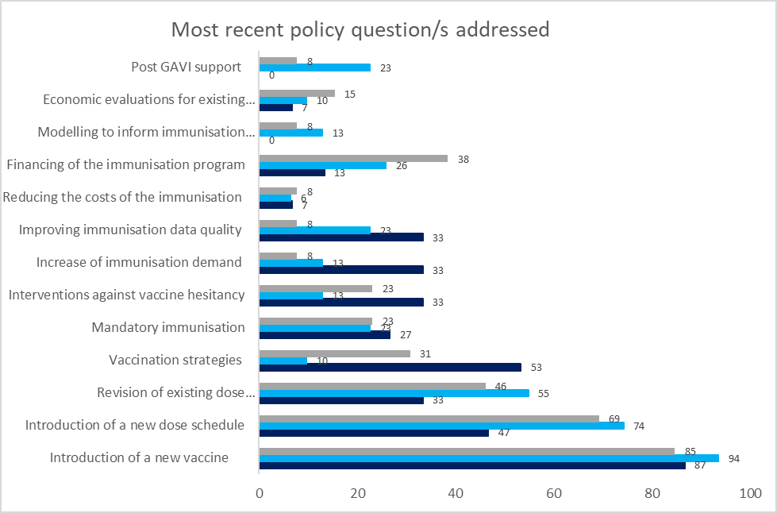

**14. What types of evidence did you use to address the recent policy question/s that your NITAG has addressed or is addressing? Select all that apply**.

Answers were provided by the following:

1. Chairs (n=15): representing 15 countries
2. Core members (n=31): representing 13 countries (*4 countries different to those of the chairs*).
3. Secretariat (n=13): representing 12 countries (*4 countries different to those of chairs and secretariat*). Note, 1 member did not answer the question

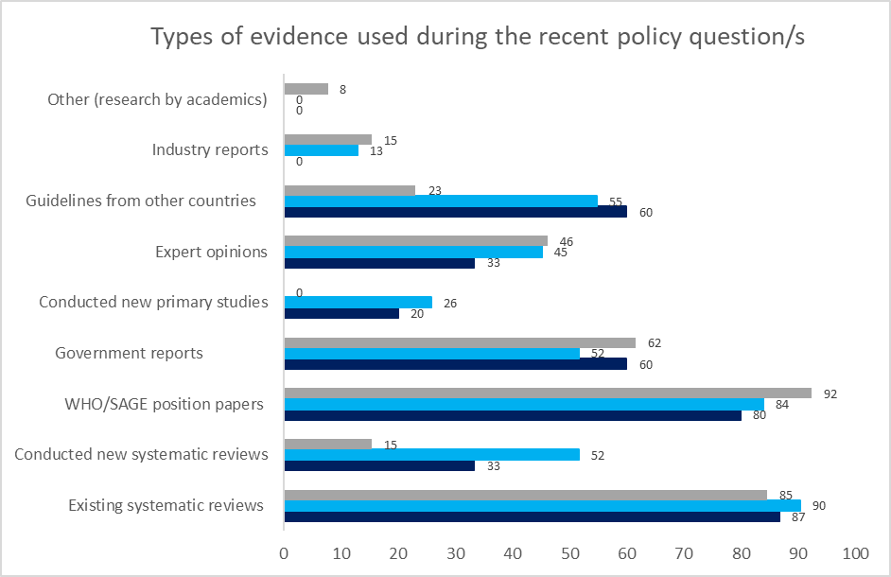

**15. What are the areas of scientific support that you would have wanted when your NITAG was working on the recent policy question? Select all that apply.**

Answers were provided by the following:

1. Chairs (n=15): representing 15 countries
2. Core members (n=30): representing 12 countries (*4 countries different to those of the chairs*). Note that 1 member did not answer the question
3. Secretariat (n=13): representing 12 countries (*4 countries different to those of chairs and secretariat*). One member did not respond to the question.

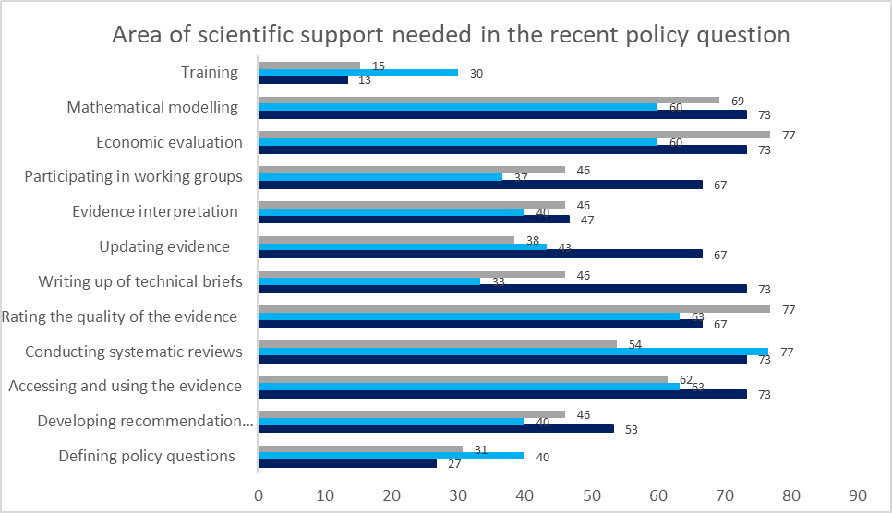

**16. Who provides funding for your secretariat?**

|  |  |
| --- | --- |
| **Country code** | **Funding of the NITAGs** |
| A | Technical partner |
| B | None |
| C | MoH, voluntary |
| D | GAVI, UNICEF |
| E | MoH |
| F | MoH, WHO |
| G | Research centre, CDC |
| H | GAVI |
| I | GAVI |
| J | MoH, OOAS (WAHO), AMP |
| K | MoH |
| L | MoH, WHO |
| M | WHO, GAVI |
| N | MoH, UNICEF, WHO |
| O | GAVI |
| P | MoH, WHO |
| Q | MoH |
| R | MoH, WHO, CHAI |
| S | MoH |
| T | MoH |
| U | CDC (only in 2018 and 2019) |
| V | None |
| W | WHO, GAVI |

**17. List all other bodies that currently engage with your NITAG (These bodies could include health decision-making groups, formal committees, research groups or others).**

|  |  |
| --- | --- |
| **Country code** | **Bodies/committees that work with NITAGs** |
| A | None |
| B | None |
| C | EPI |
| D | Academic institutions, Research bodies, UN Agencies, Health Professional Organizations, Other CSOs |
| E | WHO |
| F | Biomedical Centre, Academics, Teaching Hospitals, WHO, MoH, EPI, Local NGOs |
| G | MoH, Pharma |
| H | MoH, ICC, Medical school, National Certification Committee for Polio; National Measles verification Committee, GAVI; EPI. |
| I | PAV (Programa Alargado de Vacinação), HPV & Cancer research groups; National committee for polio eradication |
| J | AMP, CDC/ATLANTA |
| K | WHO, UNICEF, Adverse Events Committee; National Coordination Committee; Polio Committee; Regulatory body; CoMMiC, Notifiable Medical Conditions Surveillance group, National Immunisation Expert Committee, Medical research centre, Universities, National Immunisation Safety Expert Committee |
| L | Knowledge translation and exchange, Universities in DRC, WHO, EPI |
| M | CCIA |
| N | MoH, UNICEF/WHO/PATH/SPEAK AFRICA/CCI, experts or specialists in a specific field. |
| O | UNICEF, PATH, GAVI, Food and Drugs Authority, WHO, MoH, Health Service, Ministry of Finance |
| P | Not reported |
| Q | MoH, University, and National Institute of Health |
| R | FMOH, MoH, GAVI, IVAC, WHO, UNICEF, CHAI, Polio expert review committee, National Center for Disease Control, Infectious Disease Association; Pediatric Association |
| S | Not reported |
| T | RAS |
| U | EPI |
| V | None |
| W | Not reported |

**18. List all the names and role of any other national health decision-making groups or committees in your country that you think should work with your NITAG but DO NOT**

|  |  |
| --- | --- |
| **Country code** | **Bodies that could work with NITAGs but DO NOT** |
| A | The National Society of Paediatricians, National Academy of Sciences, CAS, CCIA (Agency of all doctors acting for vaccination) |
| B | Not reported |
| C | Pharmaceuticals, Research and Advisory committee responsible for conducting program specific implementation research. |
| D | Medical Practitioners and Dentists Council, Pharmacies and Poisons Board |
| E | Gynaecologists, Pathologist, Representative of Ministry of Finance, University, Institute of Health, State Law Office, Consumer association |
| F | ICC, Polio Eradication Committee, National Institute of statistics, National Food and Drug Authority |
| G | National Regulatory Authority |
| H | Hepatitis Working Group, Related departments of the MoH e.g Childcare review |
| I | PhD students in health sciences |
| J | Direction Generale De L’acces Aux Produits De Santé, Direction Generale De L’offre De Soins Oms, UNICEF, Epidemic Management Committee, Public Hygiene Service, Research Structure |
| K | Maternal Mortality Committee; NaPeMMCo; Essential Medicines Group, National Certification Commission; CoMMiC (Committee on Morbidity and Mortality in Children under 5 years (CoMMiC) |
| L | Budget development committee of the MoH, Committee working on pharmaceutical regulation, Committee which prepares the financing proposals to be submitted to GAVI, Some Funder bodies, MoH Department making policies about pharmaceuticals and monitoring adverse reactions following utilization of medicines and vaccines |
| M | CCIA, Committees of Polio Experts, Steering Committees of mass campaigns |
| N | Not reported, I don’t know |
| O | MoH, Ministry of Education, Ministry of Finance & Economic Planning, Ministry of Environment, Science and Technology, National Polio Committee, WHO, UNICEF |
| P | Not reported |
| Q | Not reported |
| R | National Committee on Health, House Committee on Health, National Immunization Task Force, National assembly, National Council on Health; National CDC, Ministry of water resources; Environmental; National Emergency Management Agency; Port Health Authority; Education; Media houses/ information; Humanitarian Ministry |
| S | AEFI committee |
| T | CCIA-PEV (Decision-making body) |
| U | None |
| V | None |
| W | ICC |

**19. Explain whether you have enough time for your NITAG duties?**

|  |  |  |  |
| --- | --- | --- | --- |
| **Country code** | **Chairs** | **Core members** | **Secretariat** |
| A | No | Yes | N/A |
| B | Yes | N/A | N/A |
| C | No | Yes, Not reported | Yes |
| D | Barely | N/A | N/A |
| E | Yes | No (n=3) | N/A |
| F | No | Yes (n= 3)  No (n=2) | N/A |
| G | Yes | N/A | N/A |
| H | No | Yes (n=2) | No (n=2), Not reported |
| I | No | N/A | N/A |
| J | No | No, Yes | Yes |
| K | No | No (n=2) | Not reported |
| L | Yes | No, Yes | N/A |
| M | Yes | N/A | No |
| N | Yes | Yes (n=2) | Yes |
| O | Yes | N/A | N/A |
| P | N/A | Yes | N/A |
| Q | N/A | Yes, Not reported | N/A |
| R | N/A | Yes (n=5),  No (n=1) | Yes |
| S | N/A | Yes | Yes |
| T | N/A | N/A | Yes |
| U | N/A | N/A | Yes |
| V | N/A | N/A | Not reported |
| W | N/A | N/A | No |
| Summary comments | Nearly half (7/15) of the chairs do not have enough time | Majority of core members have enough time. Less than a quarter (7/30) indicated they had no enough time | More than half (7/11) of the secretariat members who responded indicated that they have enough time |

**20. How could the Regional Scientific Hub support your time constraints?**

**Chairs’ responses were as follows:**

1. **Operational:** To harmonise procedures; NITAG programme/schedules; by respecting the chronogram or making a proposal for a calendar for the various possible supports, follow up on our work; empowering to carry out the activities more efficiently and effectively.
2. **Networking and collaboration:** Network with other NITAGS; facilitate experience sharing with other countries; improve NITAG recognition.
3. **Scientific/technical:** Sharing technical expertise and data; identifying, organizing, synthesizing & interpretation of evidence; scientific support; technical support; facilitating access to evidence, by providing the tools and support to facilitate the quick analysis of data synthesis of recommendations and decisions
4. **Funding**: Funding for a permanent secretariat; employ full time secretariat.

**Core members’ responses were as follows:**

1. **Operational:** By supporting with listed activities, which would reduce the time spent on formulating recommendations and other working group activities
2. **Networking and collaboration:** Collaborative research, online conferencing/ video conferencing, organize study visit to other NITAGs (n=3). The response by the rest was “None”.
3. **Scientific/technical:** Scientific support, providing relevant documents (scientific articles, reviews, policies of other countries) on specific issues; technical support, having a shared secretariat; provide us with an updated national, regional and international database to facilitate the evaluation; help with scientific review; training; serving as a reference centre for obtaining information based on best practices; by reducing investigation time; helping with write ups; provide technical support to workshops of working groups to facilitate the progress of work; by supervision
4. **Funding**: Time is not an issue but the main constraint is money to finance meetings or exchanges via new communication technologies like video conferences using EPI provincial facilities if they were equipped accordingly; while all members are volunteers, it is important to note that it won’t be sustainable, especially if more time is needed for synthesising evidence from systematic reviews; availability of necessary resources including finance to guarantee scheduled quarterly meetings; Availability of necessary resources including finance to guarantee scheduled quarterly meetings.

**Secretariat’ responses were as follows:**

1. **Operational:** None
2. **Networking and collaboration:** Availability of evidence and recommendation notes from other NITAGs
3. **Scientific/technical:** Provide a technical consultant to the NITAG; capacity building; bringing RSH expertise in the functionality of NITAG; by supporting with quality scientific journals as well as access to database/scientific journals with required information relating to the question been asked; technical support; easier access to articles or evidence saving time spend on evidence search; offering more secretariat support (systematic reviews).
4. **Funding**: None